**Worksheet – 3.3**

**Student Name:** Vivek Kumar  **UID:** 21BCS8129

**Branch:** BE-CSE (LEET) **Section/Group:** 809/A

**Semester:** 4th **Date of Performance:** 12/05/2022

**Subject Name:** Computer Network Lab **Subject Code:** 20CSP-257

**1. Aim/Overview of the practical:**

Create a network to implement TCP/IP protocol.

**2. Task to be done/ Which logistics used:**

Create a network to implement TCP/IP protocol.

**Prerequisites:**

**S/W:**

* Laptop/Desktop
* CISCO Packet Tracer program

**H/W:**

* Main Memory - 128 MB RAM
* Hard Disk – minimum 20 GB IDE Hard Disk
* 44 MB Floppy Disk Drive
* –52X IDE CD-ROM Drive
* PS/2 HCL

**3. Steps for experiment/Code with Result/Output:**

**TCP/IP** stands for Transmission Control Protocol/Internet Protocol and is a suite of communication protocols used to interconnect network devices on the internet. TCP/IP is also used as a communications protocol in a private computer network (an intranet or extranet).

The entire IP suite -- a set of rules and procedures -- is commonly referred to as TCP/IP. TCP and IP are the two main protocols, though others are included in the suite. The TCP/IP protocol suite functions as an abstraction layer between internet applications and the routing and switching fabric.

**Common TCP/IP protocols include the following:**

* **Hypertext Transfer Protocol (HTTP)** handles the communication between a web server and a web browser.
* **HTTP Secure** handles secure communication between a web server and a web browser.
* **File Transfer Protocol** handles transmission of files between computers.

### **Pros and cons of TCP/IP:**

The advantages of using the TCP/IP model include the following:

* helps establish a connection between different types of computers;
* works independently of the OS;
* supports many routing protocols;
* uses client-server architecture that is highly scalable;
* can be operated independently;
* supports several routing protocols; and
* is lightweight and doesn't place unnecessary strain on a network or computer.

The disadvantages of TCP/IP include the following:

* is complicated to set up and manage;
* transport layer does not guarantee delivery of packets;
* is not easy to replace protocols in TCP/IP;
* does not clearly separate the concepts of services, interfaces and protocols, so it is not suitable for describing new technologies in new networks; and
* is especially vulnerable to a synchronization attack, which is a type of denial-of-service attack in which a bad actor uses TCP/IP.

**Procedure:**

Open the Cisco Packet Tracer Application in your Computer

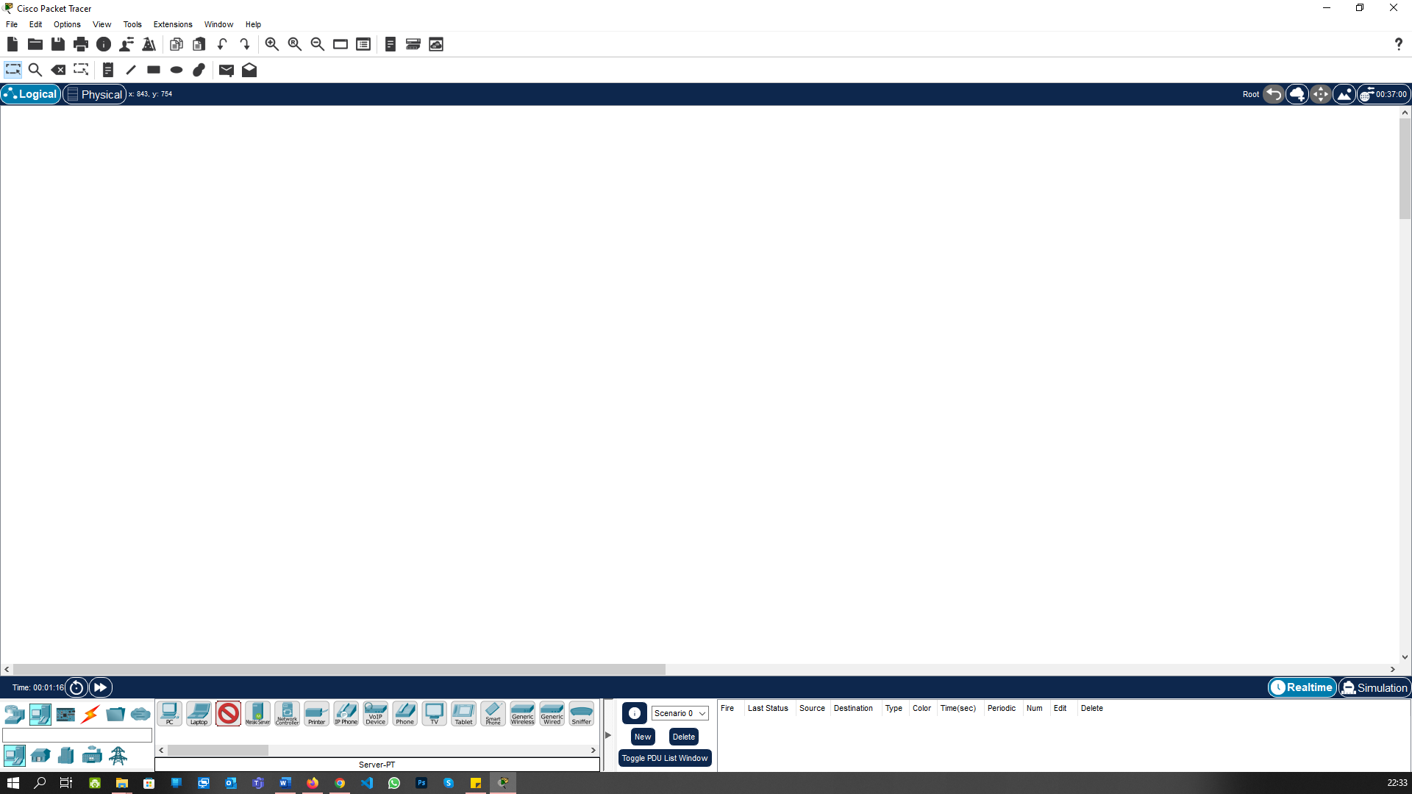

Go to the Bottom Bar “Network Devices -> Routers” and create the two Router:

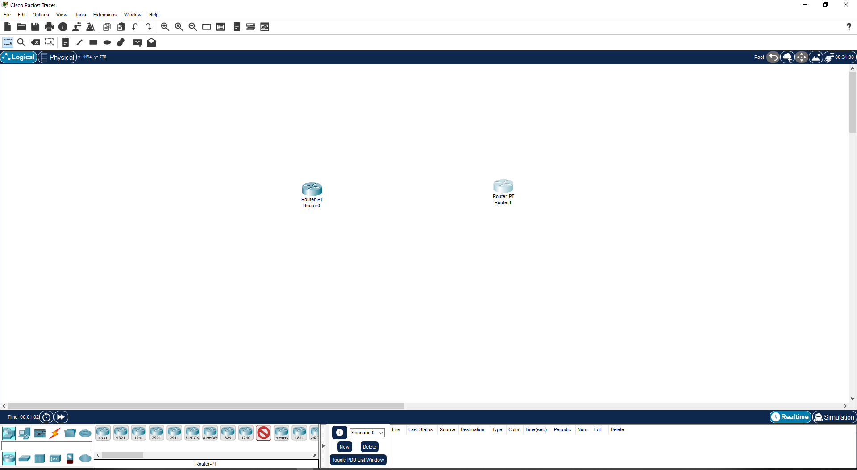

Go to the Bottom Bar “Network Devices -> Switchers” and create the two switches:

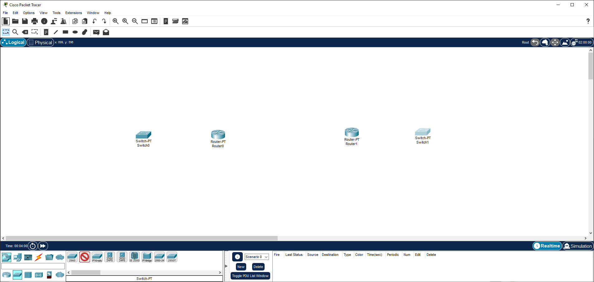

Go to the Bottom Bar “End Devices -> PC” and create the 3-3 PCs for each Switches:

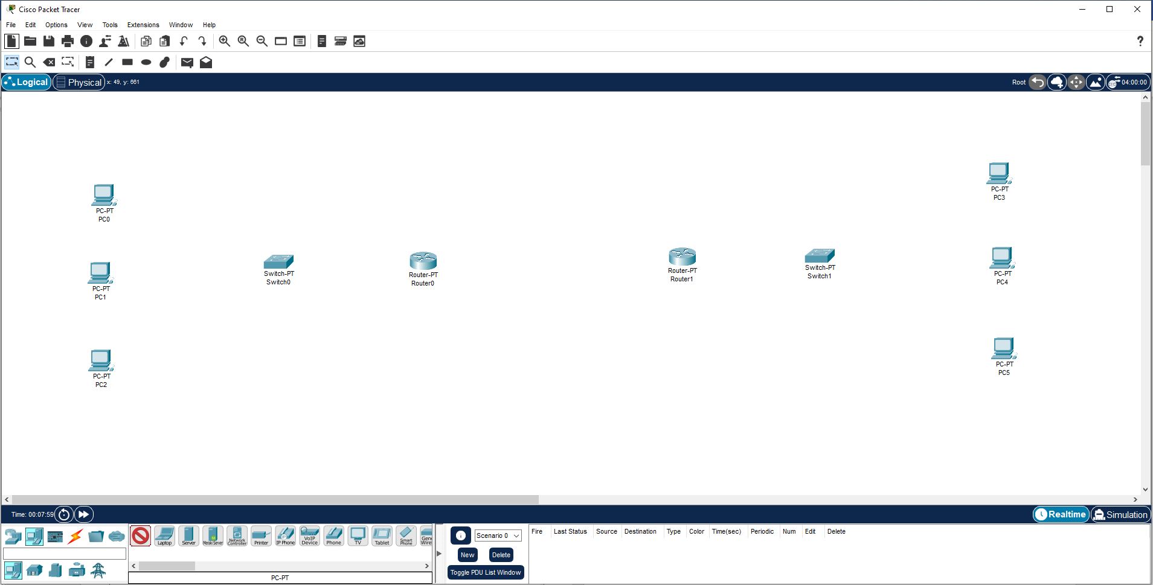

In Bottom Bar “Connections -> Copper Straight-Through” and create the connections between all the Devices:

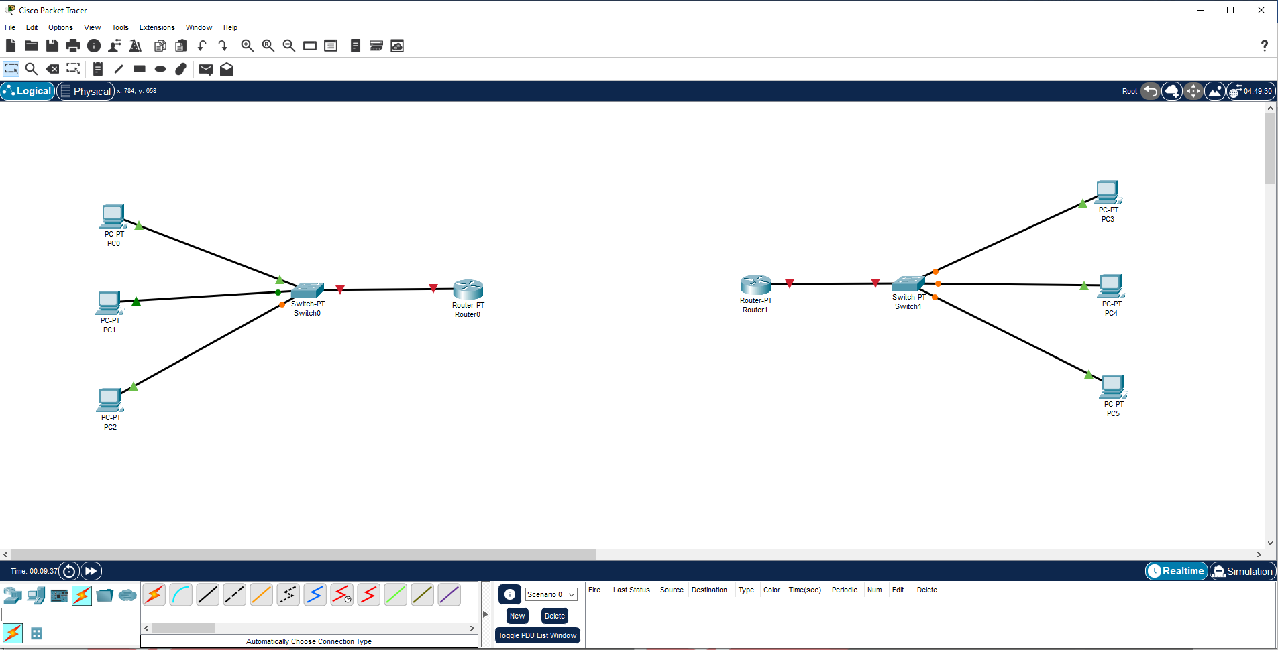

In Bottom Bar “Connections -> Serial DTE cable” and create the connections between both routers through serial port:

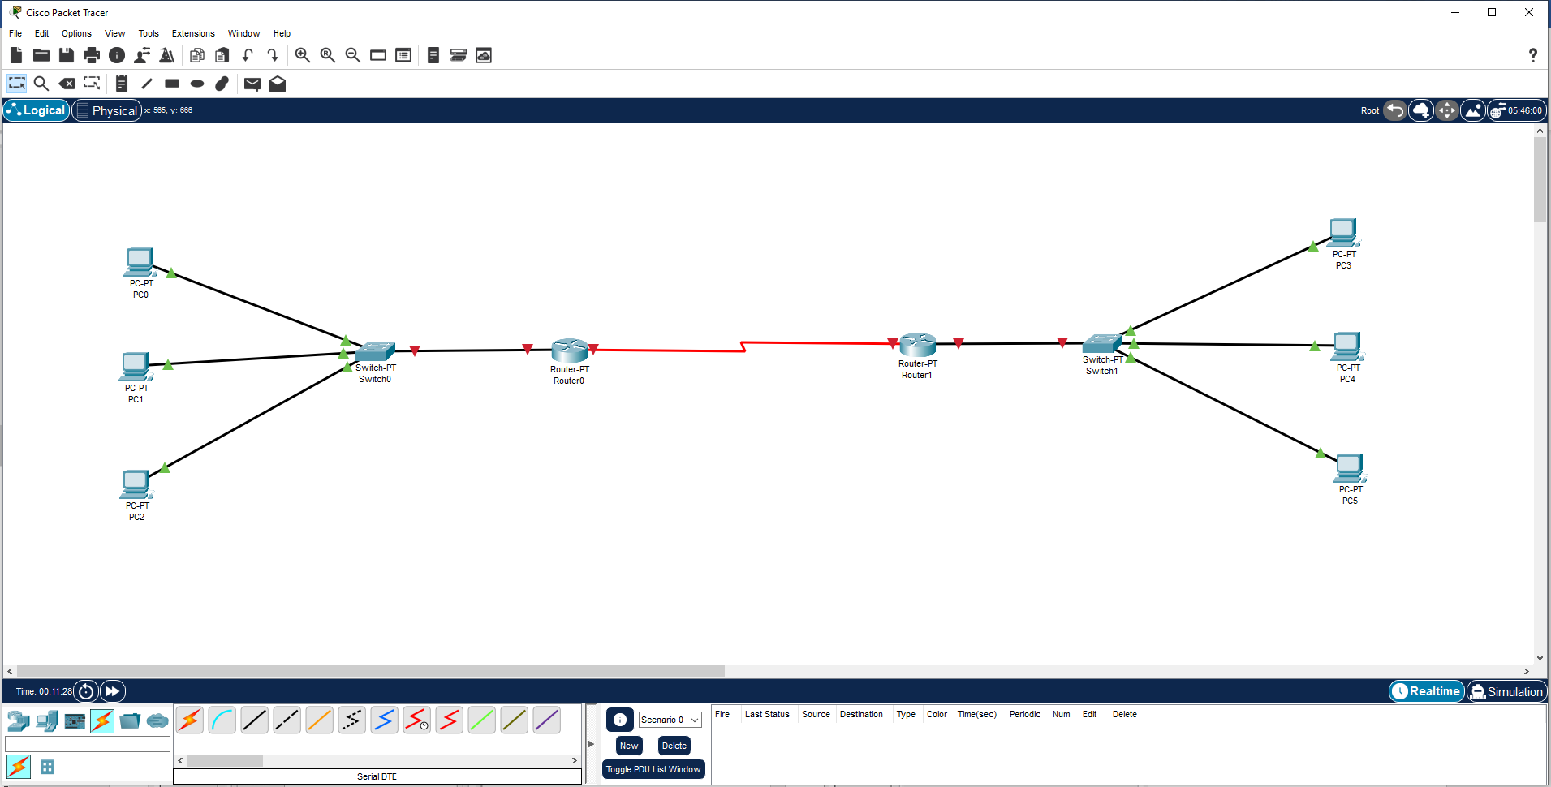

Open Router 0 configguration and in Fast ethernet 0/0 turn it on and assign the IP-Address:

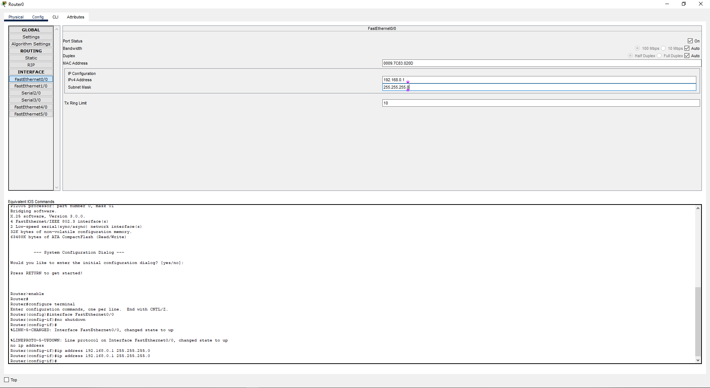

Open PC configguration and in Desktop and assign the IP-Address for all left PC, with defauld gateway which we assign to router 0:

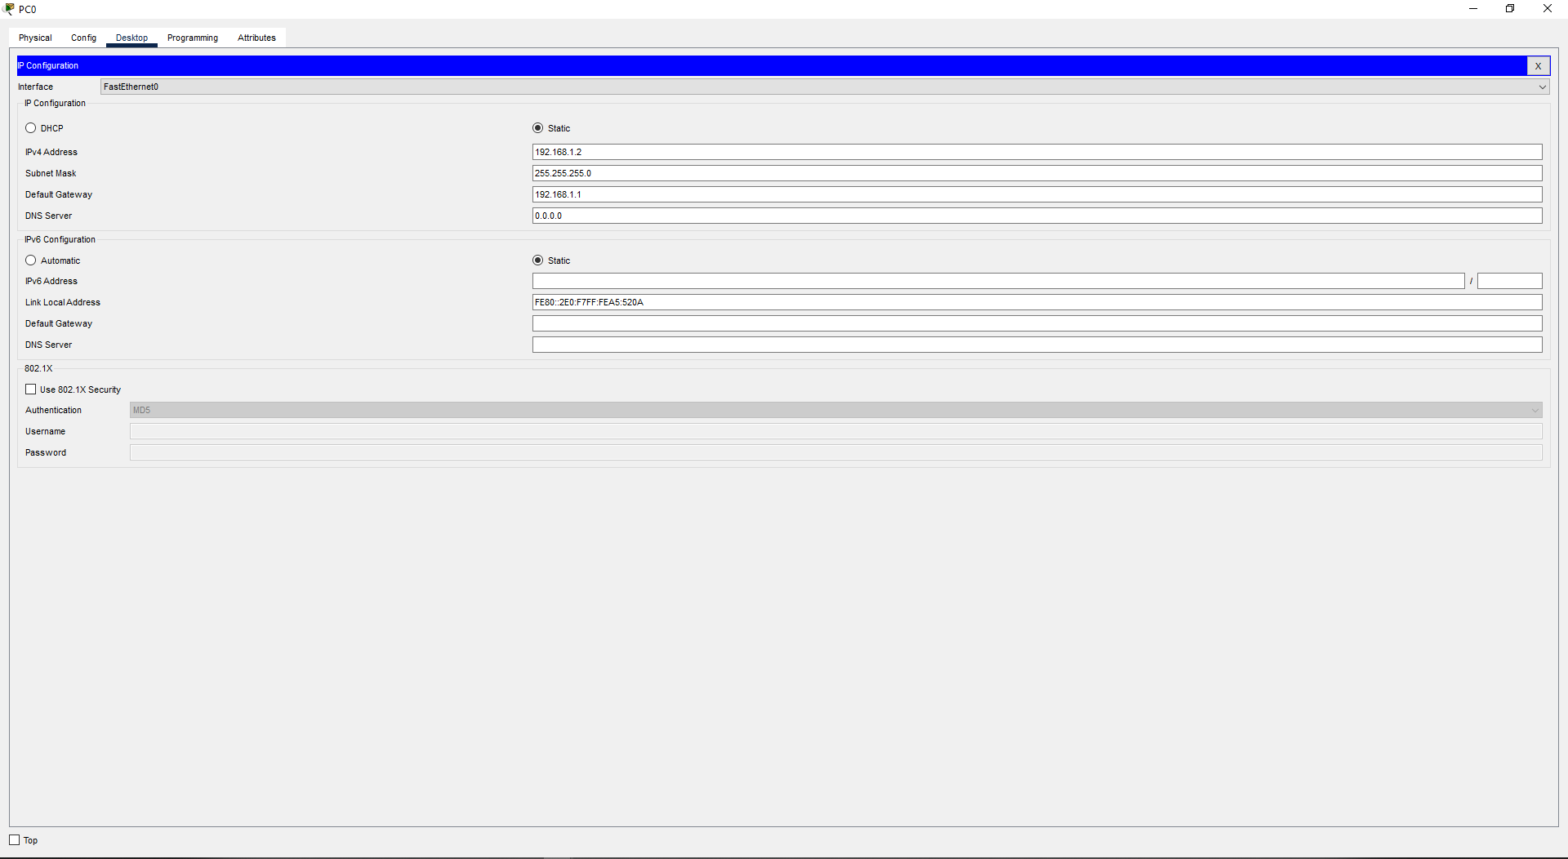

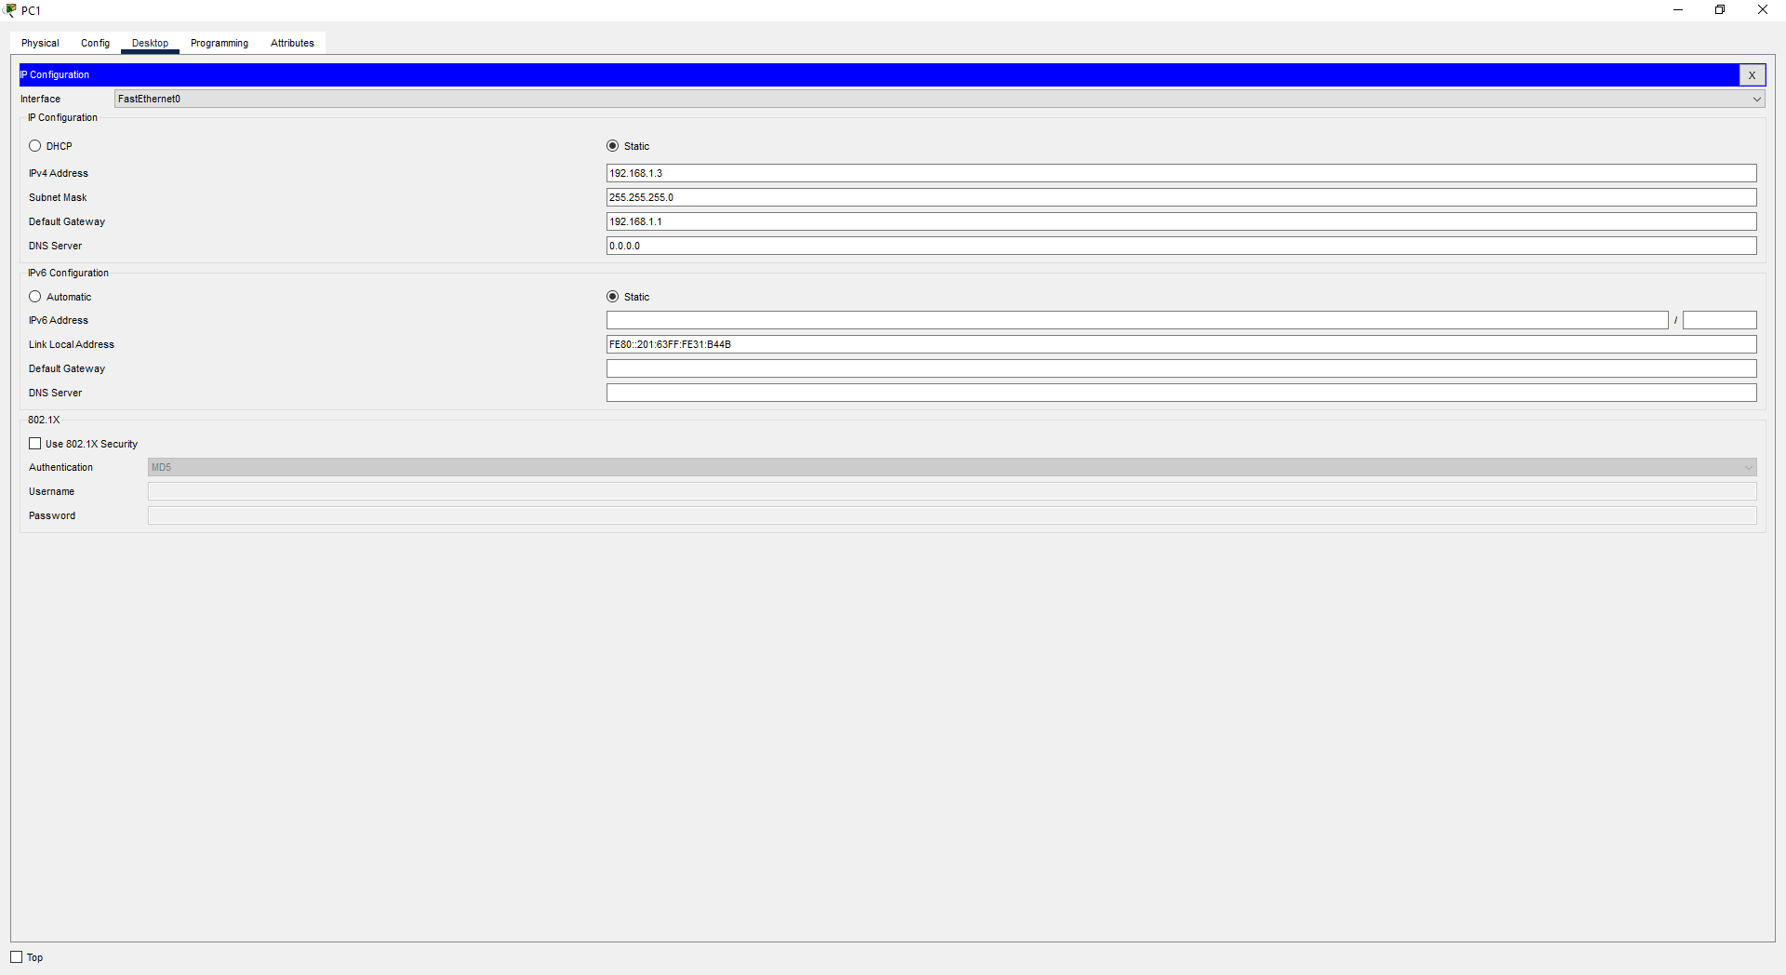

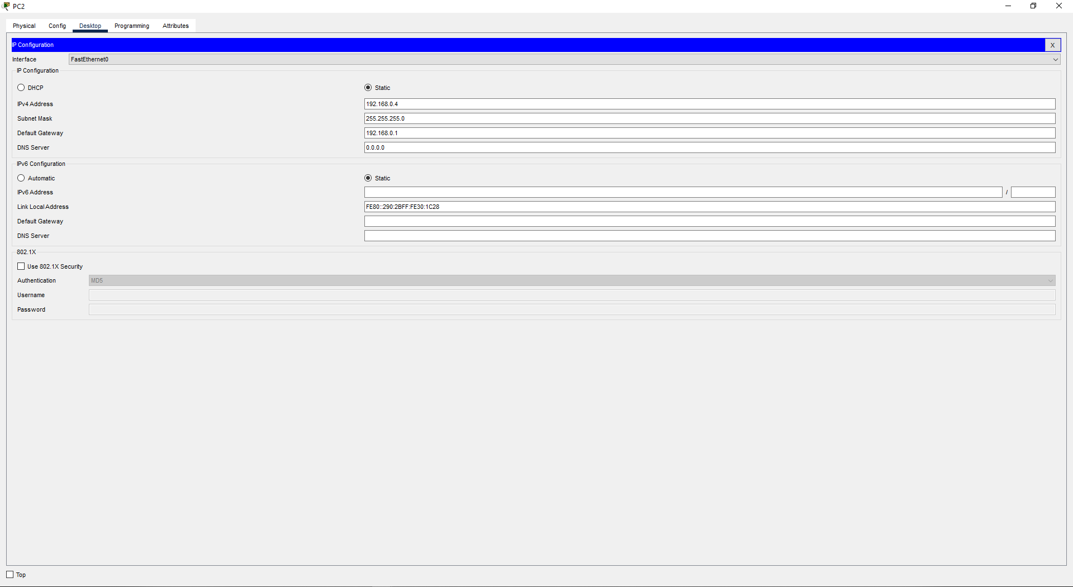

Now Open Router 1 configguration and in Fast ethernet 0/0 turn it on and assign the IP-Address:

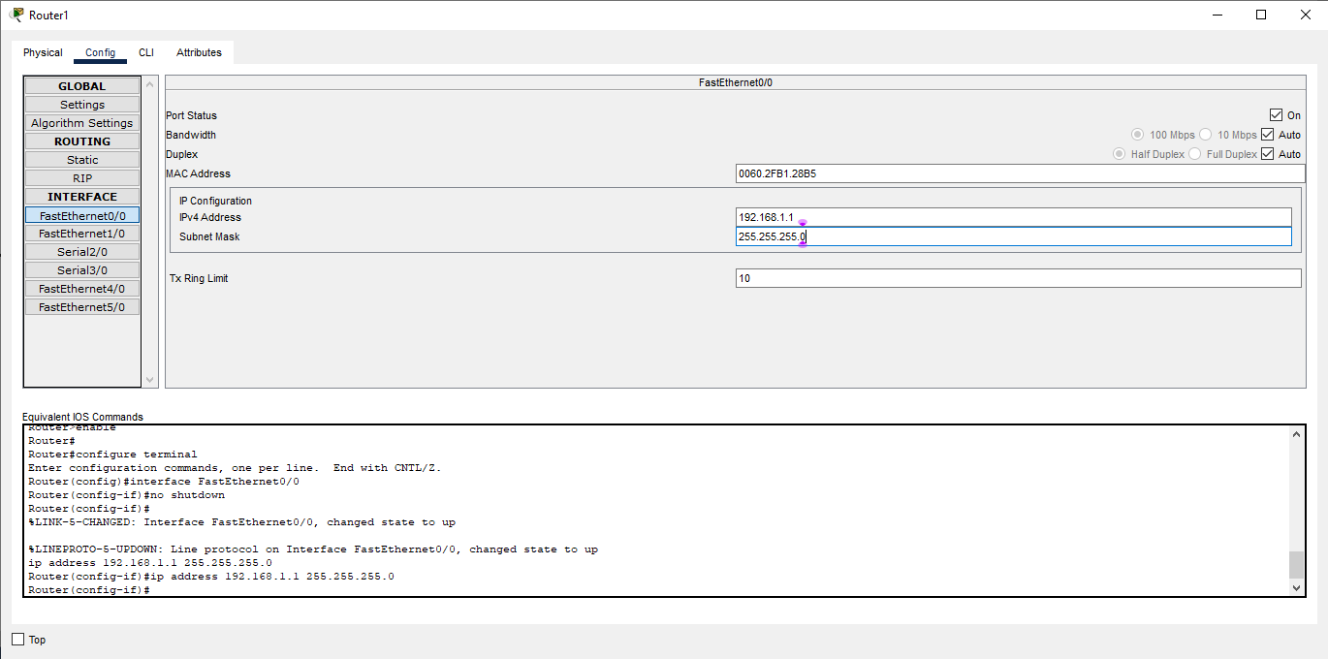

Open PC configguration and in Desktop and assign the IP-Address for all right PC, with defauld gateway which we assign to router 1:

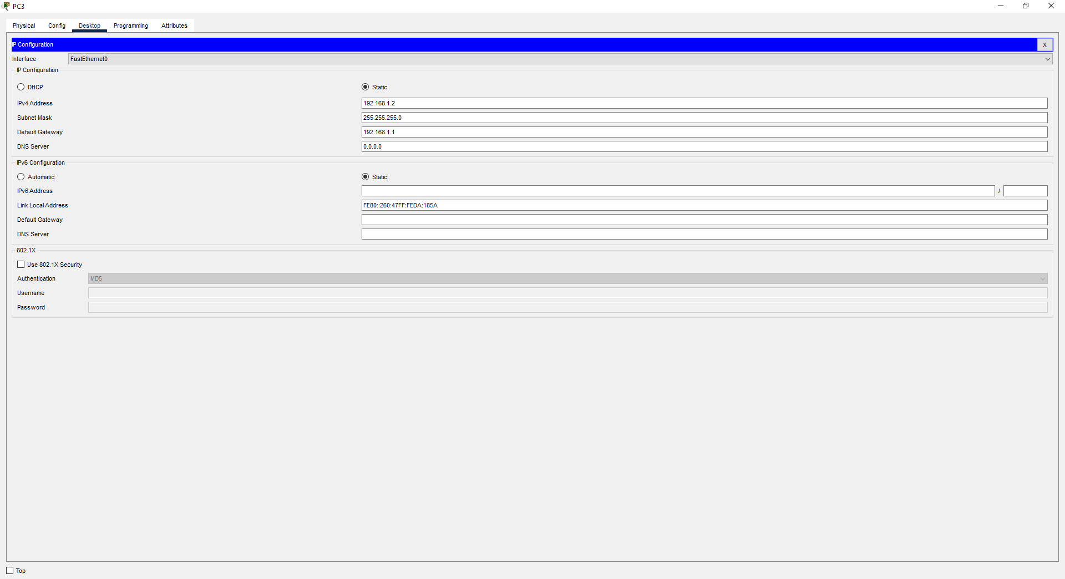

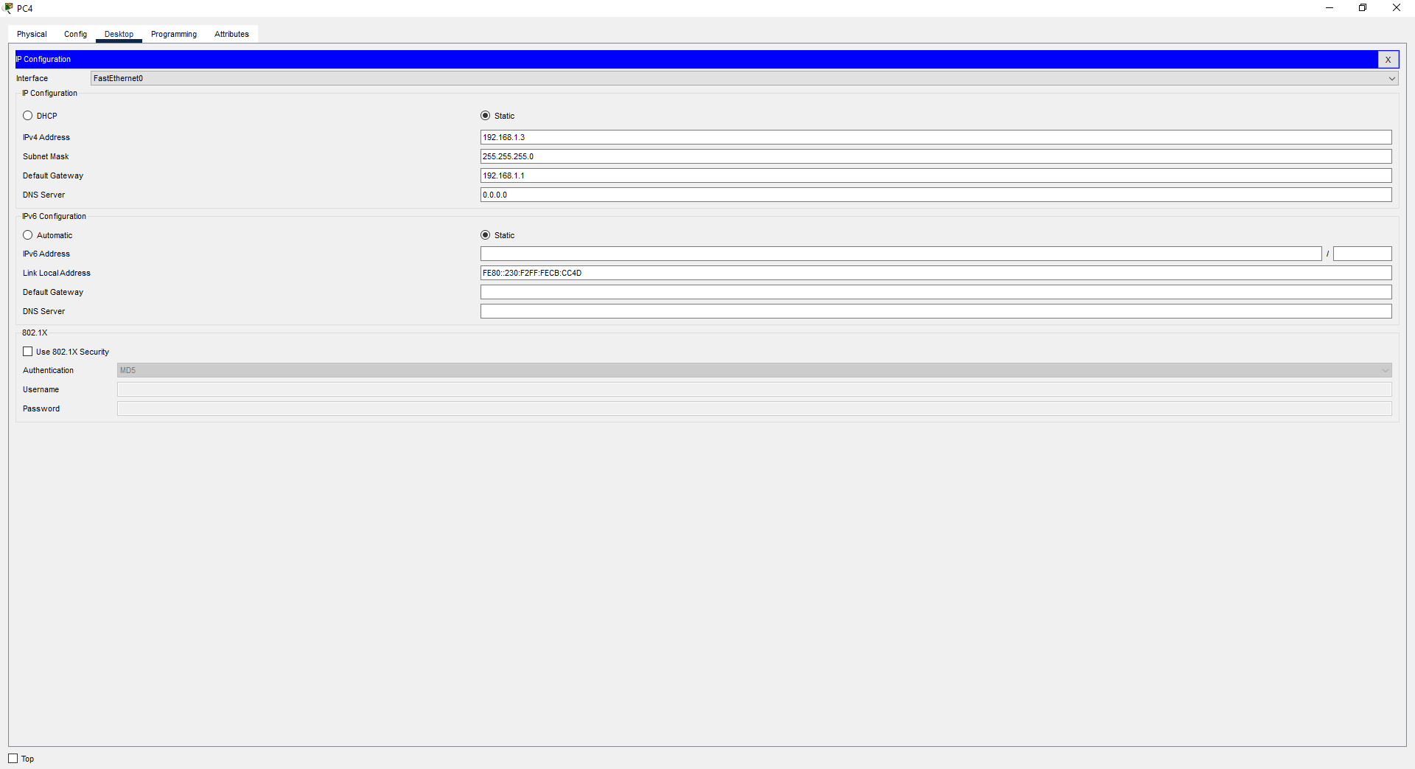

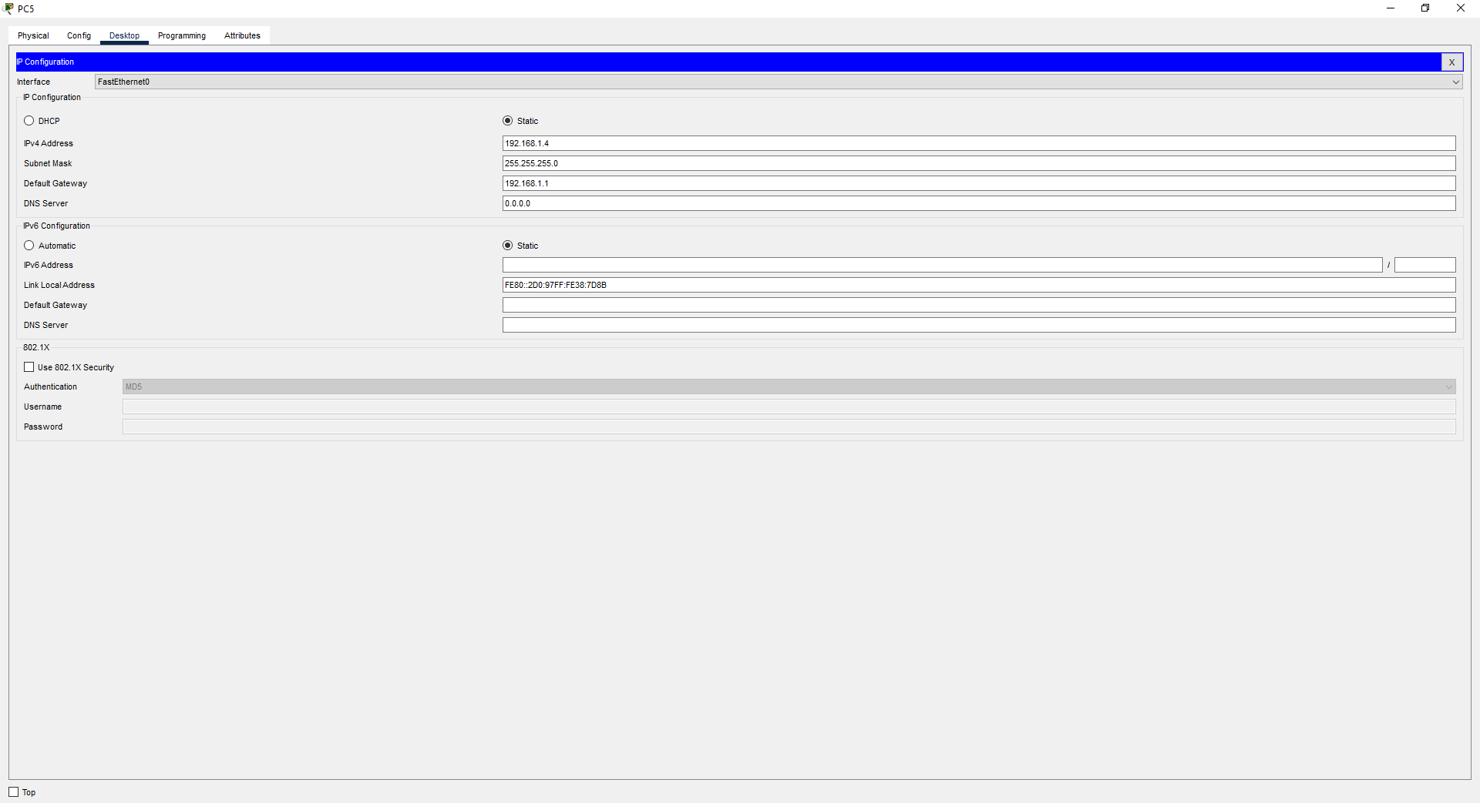

Now Open the Router 0 configuration Serial Port, turn it on change the clock speed and assign rthe IP-Address:

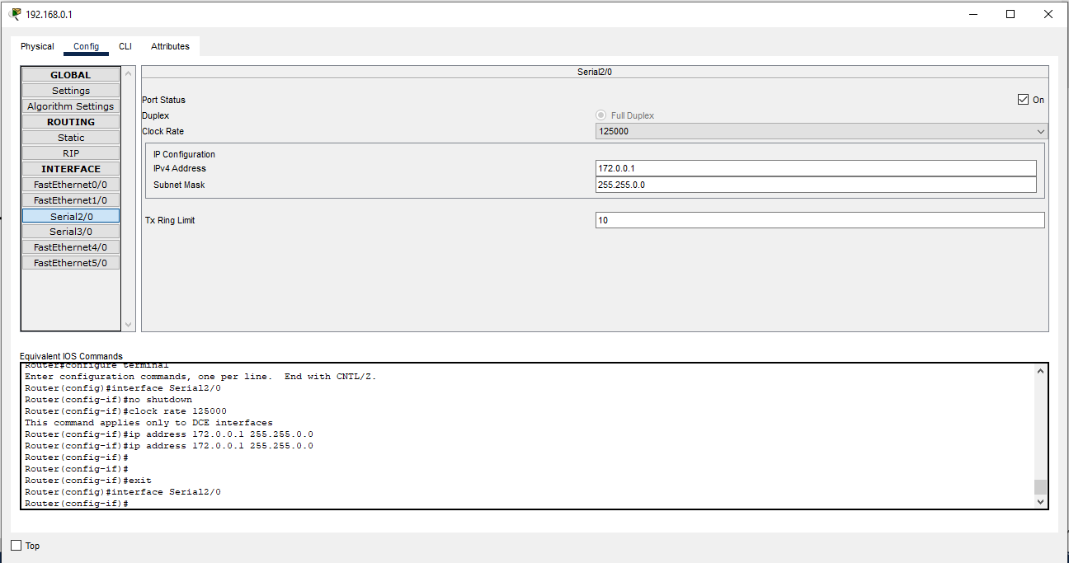

Now Open the Router 1 configuration Serial Port, turn it on change the clock speed same as router 0 and assign rthe IP-Address:

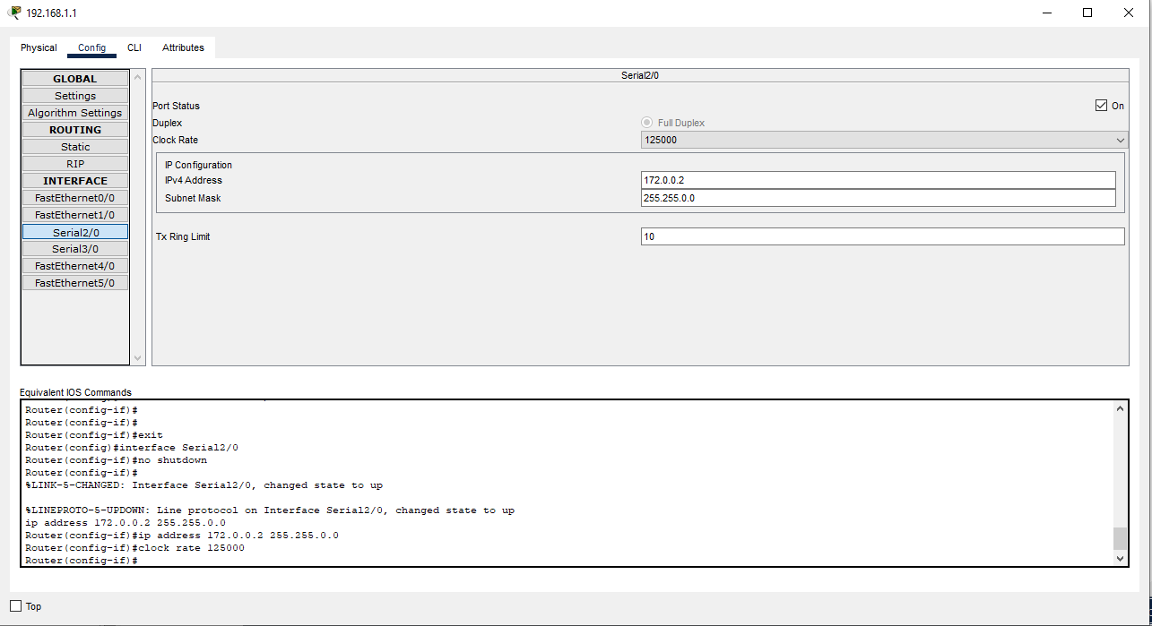

Now open the Static routing and the add the next hope and keep all network address and Mask as 0.0.0.0 and add it.

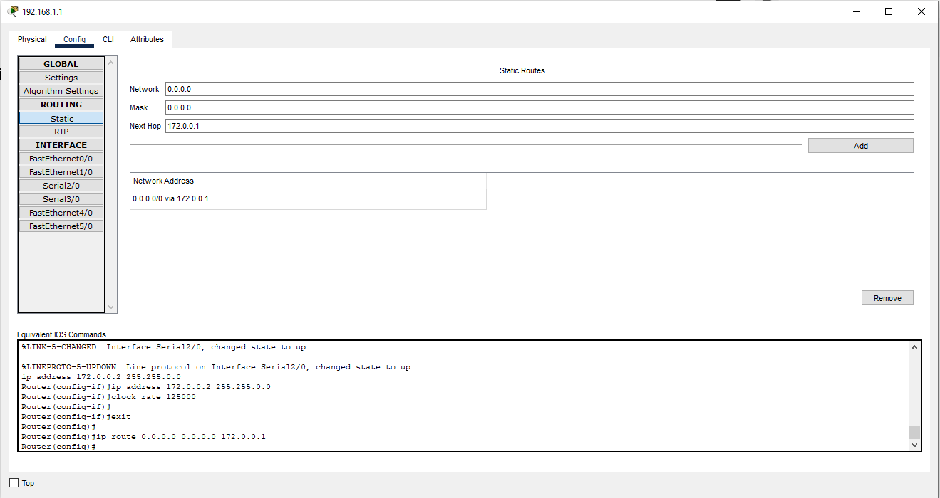

Now open Router 0 configuration -> Static routing and the add the next hope and keep all network address and Mask as 0.0.0.0 and add it.

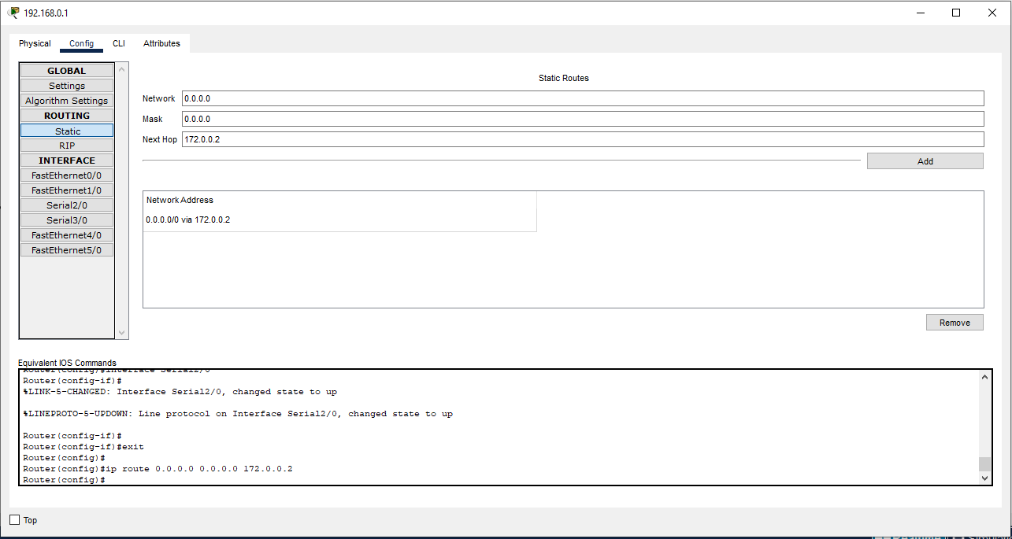

Now our connection is Completed:

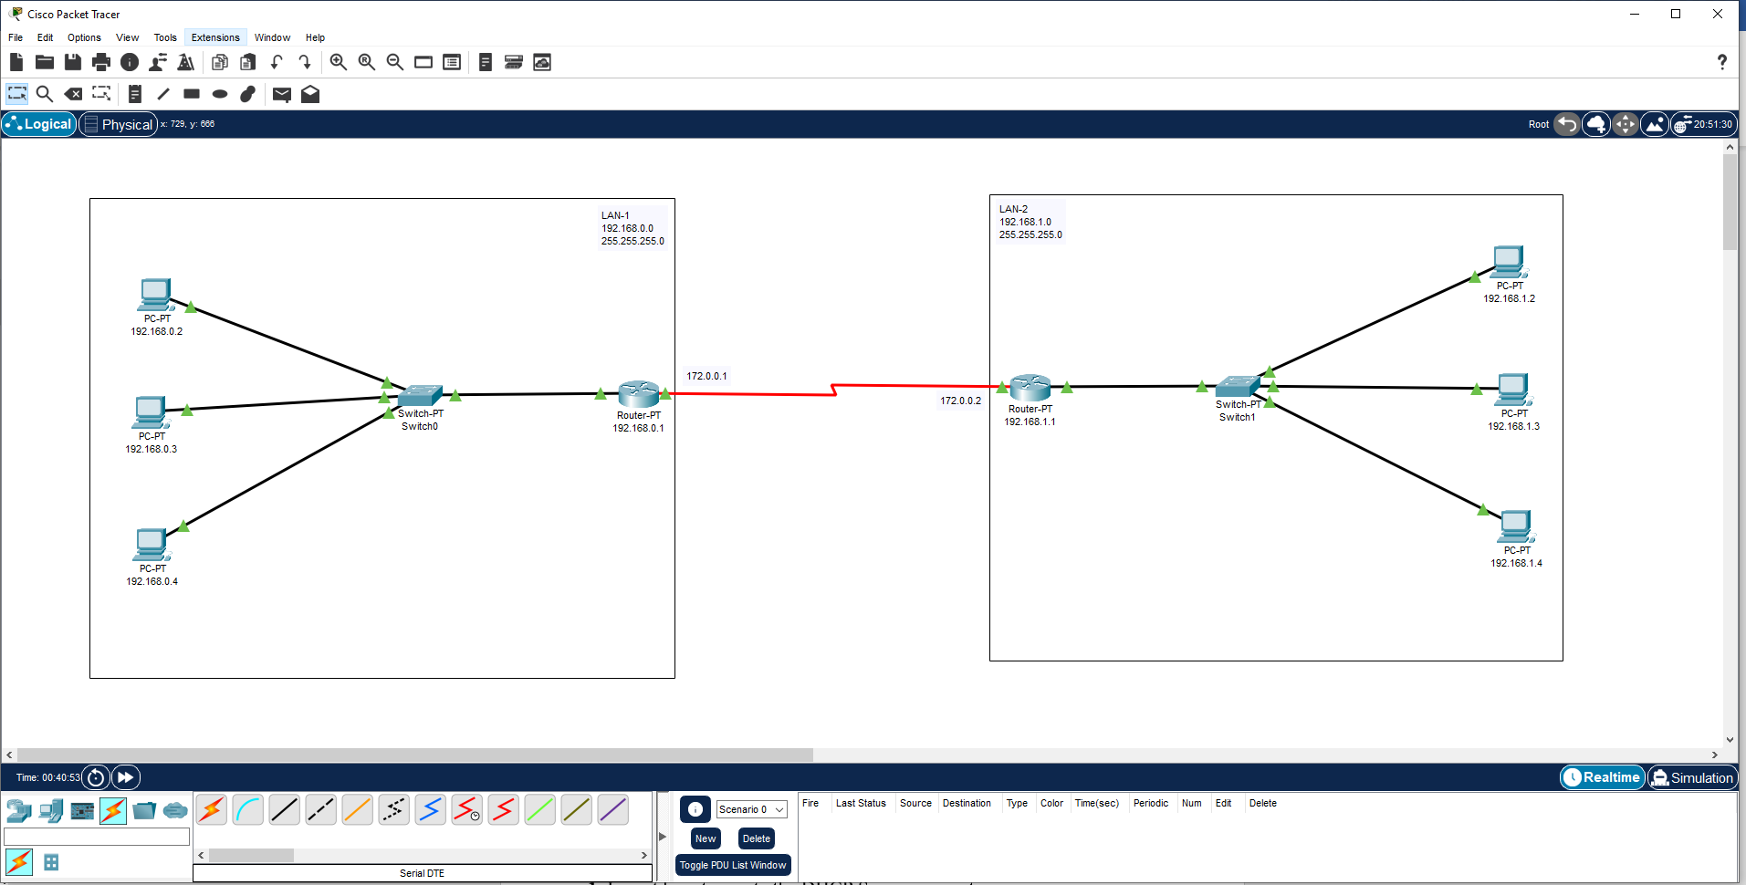

Now send the Message from device of Lan-1 to devide of Lan-2 and absorve the Simulation.

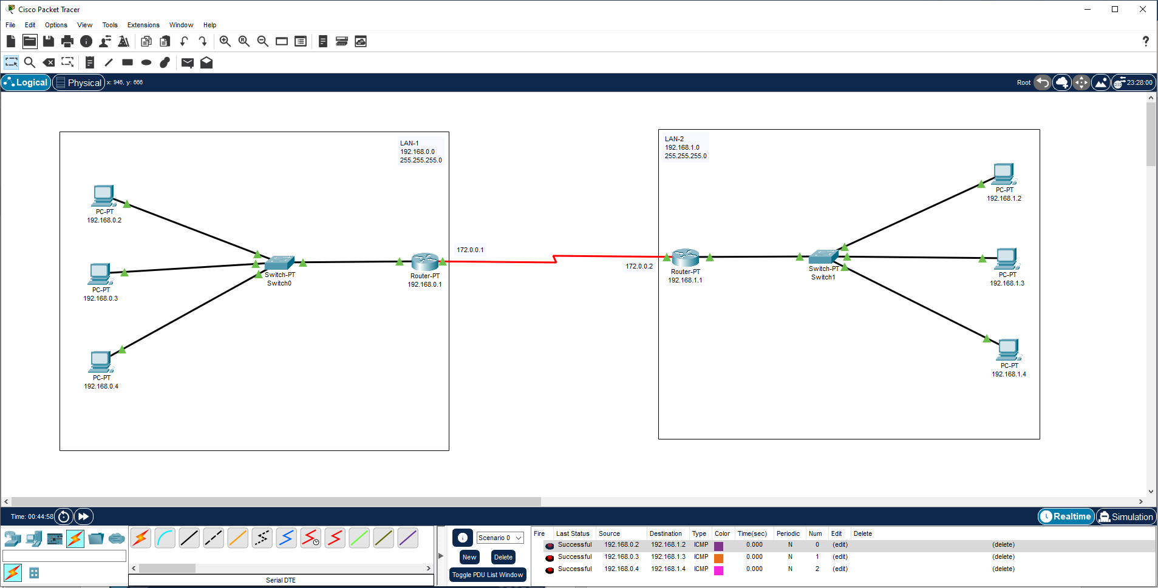

**Learning outcomes (What I have learnt):**

**1.** Learnthow to create the TCP/IP Protocol connection.

**2.** Learnt how to configure TCP/IP Protocol success fully and send the message withing two different networks.

**Evaluation Grid (To be created as per the SOP and Assessment guidelines by the faculty):**

|  |  |  |  |
| --- | --- | --- | --- |
| Sr. No. | Parameters | Marks Obtained | Maximum Marks |
| 1. |  |  |  |
| 2. |  |  |  |
| 3. |  |  |  |
|  |  |  |  |